SAPPER CHARLES VICTOR BARKER
5250 – 3rd Tunnelling Company

Born at Willaston, South Australia on 19 March 1880, Charles was the fourth born and second son of David and Hannah (nee Barden) Barker’s 10 children.

A single Miner of Mt Lyall, Tasmania, he signed the ‘Attestation Paper of Persons Enlisted for Service Abroad’ on 14 September 1915 at Claremont, Tasmania.

A medical examination on 15 September recorded that he was 35 years and six months of age, stood 5ft 4½ins tall and weighed 10 stone 10 pounds. He had a dark complexion, brown eyes and brown hair. He was of the Church of England faith. On 16 September at Claremont, Tasmania, he signed the Oath to ‘well and truly serve’ and was appointed to the 3rd Company Miners.

He named as his Next-of-Kin his brother-in-law W.C. Evans of Postal Official, South Australia. Later changed to c/o Telegraph office, Adelaide, South Australia. Later changed to W. C. Evans, Ningana Avenue, Kings Park, Adelaide, South Australia.
The Mercury, Hobart – Saturday 18 September 1915:
TASMANIA.
RECRUITING.
A BOOM SETTING IN.
The promise of the Commandant (Colonel Clark) that if possible a Tasmanian battalion shall be organised has created quite a boom in recruiting. The idea is very popular not only among the enlisted men, but with the public generally, and once it is certain that the desirable change is to be made there will be no difficulty in filling the ranks.
Since the beginning of the week there has been quite a boom in recruiting.
During Monday, Tuesday, Wednesday and Thursday no less than 184 men entered the camp. This was an increase of 73 over the figures for the same days of last week. The following are the names of the men;
C.V. Barker,
Article Abridged

His father died in March 1916 at Hammond, South Australia.

On 10 May 1916 Charles was transferred to the Miners Reinforcements at their Seymour, Victoria, training camp. On 18 July he was transferred to the Tunnelling Companies and embarked with the 2nd Reinforcements, Tunnelling Companies at Melbourne on board Armadale for the Western Front.

HMAT A26 Armadale departed Port Melbourne on 19 July 1916 with 2/Lt R.G.B. Ashcroft in charge of 78 O.Rs. making up the 2nd Reinforcements for the Mining Corps. Reaching Durban on 15 August, leave was granted from 11 a.m. to 11 p.m. before Armadale departed next day. Arriving at Cape Town on 20 August, a 3-hour Route march was organised, arriving back at the ship at 1 pm. Leave was granted until 11 p.m. with the ship to leave at 2 p.m., but cancelled and left the following day at 5 p.m. Liquor in town was considered of bad quality and as a result 10 tunnellers did not embark as scheduled on 21 August, Charles being one of them.

On 22 August Charles was charged with being absent from embarkation and drunkenness, having been arrested in town by the Civil Police. He was awarded 168 hours Detention and forfeiture of 9 days pay by the O.C. Australian Depot, Cape Town. On 24 August he was released to embark on H.M.T. Orsova.

He disembarked at Plymouth on 14 September 1916, four days before Armadale arrived at Devonport on 20 September, and marched in to No.3 Camp, Parkhouse, Salisbury.

Charles proceeded overseas to France on 17 October 1916 and marched in to the Australian General Base Depot (AGBD) at Etaples on 19 October.
He marched out of the AGBD on 23 November to join the 3rd Australian Tunnelling Company (3ATC) and was taken on strength the same day.

On 27 November 1916 at the ‘Black Watch Sap’, Hill 70, an enemy camouflet (or a premature explosion, depending on different accounts) killed 20 members of the company. The next day 2 more members were killed in the same area by an enemy camouflet. The 22 members of 3ATC were buried in 14 adjacent graves at the Hersin Communal Cemetery Extension.
WAR DIARY 3rd AUST. TUN COY – NATIONAL ARCHIVES, KEW, LONDON Ref. No: WO 95 553:

24th – 30th November, 1916
The work in progress during the previous week was continued for the remainder of the month. All the mining was done in hard chalk. The total footage at all times (12) was 214 feet. Work was considerably retarded by the charging of two mines, the blowing of one mine by us and two mines by the enemy. Rescue work and the recovering of bodies followed on the two enemy blows.

30th
Enemy work with the push pick or bayonet was heard close to no. 22 shaft R,L. (70 foot level) , being identified by 4 officers on different occasions. It was decided to blow 6000 pounds of ammonal.
At about 112 x in no. 21 DDL chamber the ground was very broken with deep cracks. Strong flow of water from face, which was plugged. In right hand corner of chamber also struck water. An enemy camouflet opposite this gallery was blown at 12.40am on 27/11/16 destroying the gallery and killing 20 men. Charging had been completed by us and tamping about to be started. Opposite no. 1 DDR1Li chamber an enemy blow took place at 8 am on 28/11/16 killing two men (Spr Allen, Joseph, 4224 and Spr Cockton, Harold, 970).

Barker, Charles Victor, 5250;Batson, William Henry, 943;
Brockley, John Robert, 2371;Christiansen, Peter Marinus, 1313;
Coulton, David, 4340;Daniels, Richard, 5253;
Edwards, Lewis Brinley, 1414;Francis, Henry Frederick, 2893;
Horton, William Francis, 1030;Kerby, Macklam James Martin DCM, 1364;
Ladd, Albert Edward, 1071;Lyons, Michael, 1273;
McLean, Hector, 4421;Moore, William James, 4402;
Nightingale, William, 4431;Pember, James, 1122;
Praed, William James, 4451;Prosser, Thomas Evan, 5014;
Reid, John, 4456; Russell, Oswald John Shaw, 4468

Red Cross files held by the AWM record:

“He (Spr Praed) was one of twenty one men who were buried in a sap and killed by an explosion of a german mine, about midday on November 27th or 28th 1916. I think he must have been killed by concussion as he only had a small mark on the back of the head and another on the left hand, I helped to carry him out and had a good look at him. He was buried at Hersin in a civilian cemetery with the others, who were killed by the same explosion. I actually saw Praed and Spr. Francis H.F., 2893, buried. Some of the other bodies were never recovered although all the names are on a memorial in the cemetery so I cannot say for sure who else is buried there.
Do not know his Christian name, he came from W. Aust. Francis came from Tasmania with me, known as Harry.”

Informant: 2891, Spr D.M. Blizzard, 3rd Tung. Coy. Private address: Forrest, Circular Head, Tasmania. Given: 6 Sept 1919 on board HMAT ‘Indarra’.

“These men were working in “Black Watch Sap” at Hill 70, close to Loos, they were loading a mine when a premature explosion took place. They were all killed outright at about 2 p.m. on 28.11.16. As far as I can remember 10 men were removed and buried at Hersin not far from Noeux, including Coulton D. 4304, and Francis H.V. 2893 and one large cross was erected suitable inscribed. I was on the same shift as these men but not on that particular job. Eyewitness to all but explosion. The party consisted of 13 men and all were killed.”

Informant: Spr D. McPherson, Brown Hill, Post Office, W.A.
Given: 5 Aug 1919 on board “Canberra”

On 28 November 1916 he was recorded as missing.

Charles Victor Barker was buried in Hersin Communal Cemetery Extension, France, at Plot 1; Row C; Grave 15, adjacent to his 19 comrades killed that day.

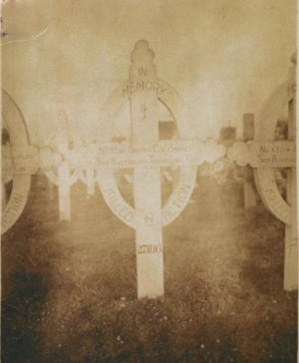
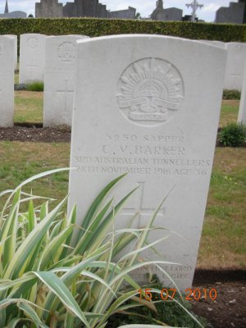
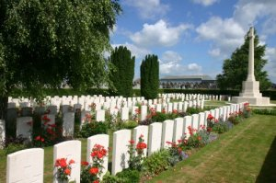
Photo of Hersin Cemetery by kind permission of
The War Graves Photographic Project - www.twgpp.org

Photo of headstone by kind permission of John Battersby, UK.
Original wooden cross image sourced from his personal file
The Register, Adelaide – Thursday 21 December 1916:
For King and Country
BARKER.— Killed in action, on the 28th November, Private Charles Victor Barker, A.I.F. beloved second son of Mrs H. Barker, 58 Cuming street, Mile-End, and the late David Barker, of Hammond, aged 36 years. His country called.
His personal effects of a disc, steel mirror in case and 2 photos were returned to his brother-in-law, W.E. Evans, Postal Official, South Australia. On 12 August 1917 Evans provided a receipt for the package of effects and inquired about Charles’ outstanding pay and any deferred pay.

On 20 October 1918 Major Alexander Sanderson, Commanding 3rd Australian Tunnelling Company, forwarded photographs of Charles last resting place.

On 21 May 1919 Major Alexander Sanderson, C.O. 3rd Australian Tunnelling Company, again forwarded photographs of Charles last resting place, noting: ‘No. 5250 Sapper C.V. Barker, killed in action by an enemy mine explosion on 27.11.16 and buried in the Communal Cemetery of Hersin, 2½ miles south of Nouex-les-Mines, France.’.

On 16 June 1920 his mother wrote to Base Records requesting particulars for War Gratuity.

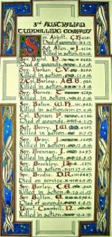
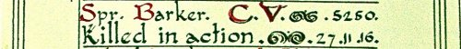
The Sydney Morning Herald - Saturday 23 July 1921:
ENGINEERS' ROLL OF HONOUR
The Royal Engineer War Memorial Committee are arranging to deposit a roll of honour of all ranks of the Royal Engineers whose names were officially published as killed in action or died of wounds or disease in the war in the chapel of St. Paul's Cathedral, and the Engineer corps of the dominions, colonial, and Indian armies have been invited to deposit similar rolls of honour in St. Paul's, to be attached to that of the Royal Engineers. This invitation has been accepted in Australia. The roll will be inscribed on vellum and enclosed in a casket of Australian timbers to rest on a slab of Australian marble.

This extract from Tunnellers Roll of Honour included in profile with the kind permission of the
Dean and Chapter of St Paul’s Cathedral, London
Photos courtesy of Robin Sanderson, Paris

In May 1922 Charles’ brother-in-law advised Base Records that the nearest blood relation to Charles was his mother, Mrs. Hannah Barker of 53 Cuming Street, Mile End, Adelaide. On 6 June 1922 his British War Medal and Victory Medal were forwarded by Registered mail to his mother, Mrs. H. Barker, 53 Cuming Street, Mile End, Adelaide, S.A..

On 27 August 1923 his mother Hannah, received his Memorial Plaque.

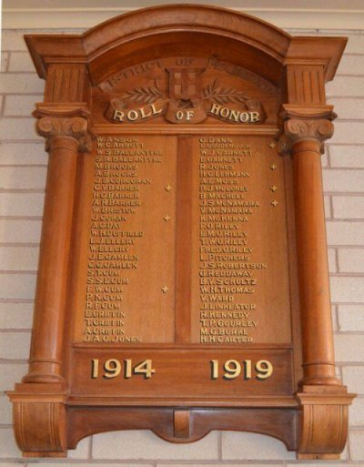
Charles Victor Barker's name is located at Panel 26 in the Commemorative Area at the Australian War Memorial, Canberra.

Two of his brothers, Harold George Barker and Archibald Ray Barker, also served in WW1.

The service of the three brothers is commemorated on the Hammond Roll of Honour at Mount Remarkable, South Australia.

Image sourced from https://monumentaustralia.org.au
photograph supplied by Rosalie Noll

© Donna Baldey 2024
www.tunnellers.net

