SAPPER PETER BAIRD
6663 – 3rd Tunnelling Company

Peter Baird was born in 1893 in Hamilton, Lanarkshire, Scotland the eldest son of Peter and Marion Murray (nee Patton) Baird. In 1901 the family were residing at 4a Portland Square, Hamilton and those present were Peter (29) coal miner, Marion (27) with Peter (7), Jeanie (6), Euphemia (4) and Minnie (8mths) with Thomas Baird (39) boarder.

It appears that Peter Baird (senior) came to New South Wales about 1912 and the remainder of his family left Southampton, England on 6 February, 1913 on the New Zealand ship Rangatira for Sydney and those arriving on 20 March were: Mrs Baird (39) housewife, Peter (19) son, Jeannie (18) daughter, Euphemia (16) daughter, Robert (10) son, Lizzie (8) daughter, Maggie (3) daughter and May (1) daughter.

Details of the voyage was published in the:

He went to work at the Vale of Clywdd Colliery, Lithgow.
Daily Telegraph (Sydney) Friday March 21, 1913:
MORE IMMIGRANTS – 1100 BY THE RANGATIRA
The disagreeable muggy atmosphere added to the troubles of the crowd waiting at Dalgety’s White Star Wharf, Miller’s Point, yesterday, in anxious expectancy of the arrival of the Rangatira, with some 1100 immigrants aboard. The vessel arrived inside the Heads about 11 o’clock, but owing to the medical inspection, and the landing at the quarantine station of some 46 cases of measles, she did not berth until after 7 p.m. As a result, a large number of people were kept waiting for many hours.
Whatever may be said of the misrepresentation in England with regard to the possibilities of Australia, the fact that of the large compliment of passengers by far the majority were nominated, speaks for itself. The number was made up for the most part of wives and families coming out to join husbands, and those facts alone would suffice to impress the views that New South Wales had proved a land of full and plenty for many who have tried their luck here. There was a fair sprinkling of labourers and artisans, with seven domestic and 14 boys for the Dreadnought Farm.
The voyage was without incident. The outbreak of measles in the latter stage.
Captain Lowden, master of the vessel, and the other officers, speak very highly of the class of people in this particular contingent, especially of the children, who number a hundred or so, and the conduct of all on board led an officer to describe the trip as one of the most successful ever made by the vessel. Article abridged
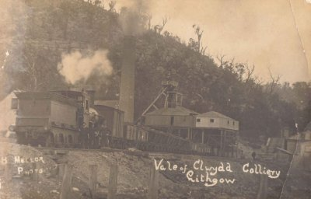
Vale of Clywdd Colliery, Lithgow, NSW
Original photo by H. Mellor and sourced from Family History Lithgow images

At the recruiting depot at Victoria Barracks, Sydney (2nd Military District) on 16 October, 1916 the single twenty-three-year-old miner applied to enlist for active service abroad and passed the preliminary medical examination.
Personal particulars taken show he was 173cms (5ft 8ins) tall with a chest expansion of 83-90cms (32½-35½) with address given as Vale of Clywdd, Lithgow. Declared fit his application was accepted by the recruiting officer.

Attestation forms were completed and describe him further weighing 61.8kgs (136lbs) with a dark complexion, good vision in his brown eyes and dark hair. Physical development was good with a pulse rate of 75. Distinctive marks were a scar on left buttock, birth mark below left scapula and a mole on right back. Religion was Presbyterian. Next-of-kin nominated was his father Peter Baird Vale of Clywdd, Lithgow, NSW and later changed to New Road, Lithgow.

He reported to the Royal Agricultural Show Ground, Sydney on 23 October, 1916 and signed taking the Oath of Allegiance and two days later was sent to the Engineer Reinforcements for basic training.

During final home leave to Lithgow the following presentation took place and reported in the:
Lithgow Mercury Wednesday November 22, 1916:
PRESENTATION TO PTE. P. BAIRD
Quite a large number of members of the Lithgow Miners’ lodge assembled at the Trades Hall, on Saturday night to bid farewell to Pte P. Baird, on the eve of his departure for the front. Mr W. Barnes occupied the chair, and proceedings opened with the usual loyal toast, proposed by the chairman.
Mr B. Rogers proposed “The British Empire and Her Allies,” they were all proud of the fight being put up by the Allied soldiers on behalf of the Empire, and to rid the world of brutal militaries. He hoped that before long their efforts would be crowned with success.
In proposing “Our Soldier Guest,” Mr Tom Norwood, who had known Pte Baird for a considerable period, spoke of his good qualities. He felt sure that there would be nothing lacking in their comrades’ record. He had proved himself a true citizen. The toast was received with much gusto and three ringing cheers.
The chairman, on behalf of the lodge, asked Pte Baird to accept a wristlet watch as a token of their esteem. They all knew what a loyal comrade and true unionist their guest had been, and he felt that when the opportunity arrived, he would give a good account of himself on the battlefield. (Hear, hear.) They all hoped to welcome him back again. (Applause).
Mr Sneddon, on behalf of himself and a few personal friends of the guest from the Vale of Clywdd lodge, presented Pte Baird with a nice cigarette holder in case.
In responding, Pte Baird said, nothing in his life moved him so much as that gathering. It was very encouraging for a man who had enlisted to receive the compliments of his fellow workmen in that manner. He had always endeavoured to do the right think in Lithgow as a citizen and a unionist. His mind was made up to act upon those lines as a soldier. He thanked the lodge for its present, and also his friends from the Vale for their token of firm friendship. Both gifts would remind him of the good days he had spent in Lithgow, and the friends he left behind. (Applause.)
Mr J. Hammond proposed “Lithgow Lodge and the Miners’ Federation.” He trusted the members would record a vote that would be worthy of them at the ballot to be taken.
The proceedings terminated with the toasts of the press and chairman, respectively. During the evening harmony was contributed by Pte Baird, Messrs Hardy, Norwood, O’Connell, McGregor, Arnott, Sneddon, Drown, Delaney, Boswell, Collins, Spiers, McDermott, and R. Northey.
Pte Baird left for camp by the mail train on Sunday night.
Article abridged

Australian Town and Country Journal (Sydney) Wednesday November 29, 1916:
LITHGOW
A number of members of the Lithgow Miners’ Lodge assembled at the Trades Hall recently to bid farewell to Private P. Baird, on the eve of his departure for the front. Mr W. Barnes occupied the chair, and on behalf of the lodge asked Private Baird to accept a wristlet watch as a token of their esteem.

On 24 November, 1916 was transferred to the Tunnelling Companies training camp at Seymour, Victoria joining the January, 1917 Reinforcements on 8 January. His rank was Sapper with the regimental number 6663.

The Reinforcements consisting of 168 members departed Melbourne, Vic at 3 p.m. on January 17, 1917 on board the HMAT A5 RMS Omrah.
The mail ship arrived at 8 a.m. two days later at Adelaide, S.A. and headed off at 4 p.m. that afternoon. It sailed into the West Australian port of Fremantle on January 21 where the Reinforcements were granted Day Leave ashore the next day before leaving on January 24, 1917.

The ship returned to Fremantle at 7 a.m. on February 1 and put out to sea again at 5 p.m. the next afternoon February 2. Durban, South Africa was reached at 7 a.m. on February 16 and sailed at 6 p.m. the following evening.

The next port of call was Cape Town on February 20 arriving at 8 a.m. where two days later the men were granted Day Leave ashore until 11 p.m. on the 22nd before departing at 5 p.m. on February 24. The sights of Sierra Leone were seen closely on March 9, 1917 as the vessel docked at 8 a.m. and after refuelling left at 7 a.m. on March 12, 1917.

The voyage concluded at Devonport on March 27, 1917 and the troops disembarked at Plymouth after 74 days at sea. The three officers and 165 other ranks were detrained to Tidworth for further training at the front at Parkhouse.

The Reinforcements left the Drafting Depot on 14 April, 1917 proceeding to France from Folkstone arriving at the Aust General Base Depot a day later.

Was sent to the 1st Anzac Entrenching Battalion which was an advanced section of the Base Depot that organised works near the lines and through duties, usually of ten days duration, would accustom the reinforcements to war conditions before being assigned to a company in the field.

After three days there was admitted on 24 April with Scabies (a skin irritation caused by Itch Mite whose eggs are laid under the skin’s outer layer) to the 35th Field Ambulance then moved to the 14th Field Ambulance Casualty Clearing Station.

On 7 May entered with dermatitis to the 5th Divisional Rest Station at the 8th Aust Field Ambulance until discharged to his unit on 13 June, 1917.

On 8 September, 1917 was taken on strength with the 3rd Tunnelling Company.

During September in the permanent tunnel systems of Hulluch – St Elie – Vermelles Sector, work was continued in extending the subways and dugout accommodation for garrison troops, in maintaining an efficient state of sanitation and repair, and in “Listening” in the mine listening galleries in advance of the Front-Line Trenches.

His name was included on the Miners’ Roll of Honour with those recorded published in the:
Lithgow Mercury Friday November 9, 1917:
THE MINERS’ ROLL OF HONOR
This roll, which has graced the eastern inner walls of the hall for several months, is also 20ft, wide by 13ft high. The base is painted light yellow, surrounded by a neat green border. Along either side painted flagstaffs extend the whole length. At the top flags, representing the Union Jack and the Australian ensign, spread out. On a crescent of dark red which is joined by an inverse crescent or ribbon effect, are the words in silver: “Coal and Shale Employees’ Federation, Western Branch.” Our Boys serving their Country” is also attractively arranged above eight ornate columns or panels in which the names are set out in the following order: [No. 15] P. Baird Article abridged

Two Blue Chevrons were issued to wear on his uniform for serving twelve months abroad on 17 January, 1918.

Gifts of comfort were distributed to the men from the Kalgoorlie Ladies Committee and the recipients signed the letter of thanks which was reprinted in the:
Kalgoorlie Miner Tuesday April 16, 1918:
TUNNELLERS’ COMFORTS - MEN WHO RECEIVED THEM
Sometime ago gifts were despatched to the front by the No. 1 Tunnelling, Pioneers and Engineers committee, and a list of recipients has now been received by the secretary, Mrs R.M. Jordan as follows — P. Baird,
Article abridged
Service continued without illness or injury and his whereabouts was queried on 9 July, 1918 and noted to be still serving with his unit on July 13.

Sapper was wounded in action suffering the effects of gas poisoning while clearing forward roads on 28 October, 1918.

The following was reported in the After War Report of the 3rd Tunnelling Company:

“On 28/10/18 the following O.R.’s were shell gassed in forward areas:

2374 Spr. Carr, S.P.
4487 “ Thompson, E
6667 “ Brodie, D.R.
6626 “ Halliday, F
6663 “ Baird, P.
6630 “ James, A.H.”

He was taken to the 47th Field Ambulance being admitted gassed by shell and transferred to the 15th Casualty Clearing Station. The following day was moved to the 54th Casualty Clearing Station then a day later to Base before entering the 2nd Aust General Hospital on October 31.

On 2 November he was reported dangerously ill with pneumonia.

Sapper Baird died of disease on 5 November, 1918 of broncho-pneumonia caused from effects of gas shell poisoning. He was 25 years of age. Burial took place in plot 7 of Terlincthun British Military Cemetery, Wimile, France within row C in grave no. 20.

The following was recorded in the After War Report of the Company:

“5/11/18, 6663 Spr. Baird, P. died of gas wounds at 2nd Aust. G.H., Wimereux.”

The Australian Red Cross had a wounded and missing enquiry bureau in London who kept card files on all deceased, prisoners of war or missing soldiers.

The following is a copy of a letter sent to their London Bureau about the death of Sapper P. Baird.

AUSTRALIAN BRANCH, BRITISH RED CROSS SOCIETY
Boulogne
Nov. 7th, 1918
The Sec,
Wounded missing enquiry Bureau,

Dear Miss Deakin,
Sapper P. Baird No. 6663 3rd Australian Tunnelling Company Died at No. 2 A.G.H. Wimmereux on 5.11.18 at 2.25 (a.m.) and was buried at Terlincthun Cemetery on the 6th.11.18. Grave Number 7 C 20.
He was admitted in to the No. 2 A.G.H. on 31st October, 1918 and came from 32 C.C.S. He died of being gassed and Broncho-pneumonia.
Yours sincerely,
H. Hanna

Base Records advised his father on 9 November, 1918 that he had been reported gassed, classed as wounded and the 2nd Military District was advised on November 11 that he had died on November 5 with the news conveyed via local representatives to the family.

This news was shared in the:
Lithgow Mercury Monday November 18, 1918:
DEATH FROM ILLNESS
SAPPER PETER BAIRD
Mr P. Baird, of New-road, received word on Thursday night, through Rev. A.D. Robertson, that his son, Sapper P. Baird, of the third tunnelling corps, had died of broncho-pneumonia, and the effects of gas received on November 5. The sapper enlisted from here about two years ago and was prior to that working in the Lithgow colliery. Sympathy will be extended to the father in his great loss, more especially as the soldier died almost on the eve of peace.

A copy of his service was made for the Pension Department on November 20.

His name was listed in the casualty list published in the:
Farmer and Settler Tuesday December 24, 1918:
DIED OF WOUNDS – NEW SOUTH WALES
D—Sprs. P. Baird, (Lithgow), D.R. Brodie (Leichhardt) [Tunnellers] Article abridged

Base Records wrote to his father on 20 May, 1919 referring to the report on the regrettable loss of his son and was now in receipt of advice which shows he was wounded (gassed – classed as wounded) in action on 28 October, 1918, admitted to the 47th Field Ambulance and transferred to the 15th Casualty Clearing Station. The same day admitted to the 32nd Casualty Clearing Station and transferred to the 54th Casualty Clearing Station on the 29th diem. On the 31st diem he was again transferred to the 2nd Australian General Hospital in Boulogne where he died on the 5th November, 1918 as the result of his wounds (shell gas poisoning). He was buried in Terlincthun British Cemetery, 1 mile north of Boulogne, France.

The utmost care and attention were being devoted where possible to the graves of our soldiers. It is understood that photographs are being taken as soon as possible and be transmitted to next-of-kin when available.

These additional details were being furnished by direction, it being the policy of the Department to forward all information received in connection with deaths of members of the Australian Imperial Force.

On 16 June, 1919 Mr Baird wrote to Base Records from New Road, Lithgow stating that some considerable time ago he wrote asking if they could do anything in regards to his son’s personal belongings. He received a reply from them stating that they would make enquiries and since then had heard nothing.

A reply from Base Records dated 24 June, 1919 stated that advice had been received from A.I.F. Headquarters, London, that one package of personal effects of your son had been despatched to their office. When to hand they would be promptly dealt with.

As the late soldier made a statement that his Will was lodged with his mother at Vale of Clwydd, Lithgow, NSW the writer would be obliged if you would request the lady to forward same or Probate if taken out to this office at her earliest convenience, so that provision set out therein may be noted for compliance when dealing with deceased’s personal effects.

If Probate has been granted, the document will be passed directly to Military Paymaster, Victoria Barracks, Sydney, for notation and transmission to you.
If Probate or Letters of Administration have not been taken out, and the Will is not required for this or any other purpose in connection with the distribution of the estate it will be passed to the abovementioned authority for the payment of monies – should it be required by you for further action, it will be returned after notation.

Mr Baird replied on 15 July, 1919 to his son’s statement that his Will was lodged with his mother. I may say that we had a letter from him when he embarked on the 17 of January, 1917 for England and he left all his money to his mother 4 shillings a day and he kept one to himself and 1 deferred and if anything happened to him his father would get that deferred money so that is all the Will I have got.

In their reply to Mr Baird, Base Records stated that his son made a statement to the effect that his Will was in the custody of his (Mother) Mrs M. Baird, it will be necessary for Mrs Baird to furnish to this office a Statutory Declaration made before a Justice of the Peace, that the Will is not in her possession, nor has she any knowledge of such document. At the same time, I would be obliged if you will forward on loan to this Branch, the letter mentioned by you, in order that we ascertain whether same could be regarded in the nature of a Holograph Will.

On 1 August, 1919 Mr Baird replied to Base Records re the loan of the quoted letter he stated I am making a Statutory Declaration before a Justice of the Peace that the contents of the letter read as follows: (I have left all the money to you 4/- a day and 1/- to myself and shilling deferred pay. I thought I could leave you 5/- shillings but the most I could leave is 4/- the Government claims the other 1 shilling but you get it when you come back and if anything happens to me the next-of-kin draws that 1/- so that will be my father.)

The Statutory Declaration by Mr Peter Baird states:
New Road,
Lithgow
1-8-19
I, Peter Baird,
Solemnly declare that the contents of copy attached to this declaration are exactly the same as
Written by my son the late No. 6663, Sapper P. Baird of No. 3 Tunnelling Company.
Signed: Peter Baird
Father
Taken and sworn before me this first day of August in the year of our Lord
One thousand, nine hundred and nineteen.
At Lithgow
Signed: Albert Watson J.P.

The Statutory Declaration by Marion Baird reads:
New Road,
Lithgow
1-8-19
I, Marion Baird, mother of Sapper P. Baird, No. 6663, do hereby solemnly declare that the Will of my
son is not in my possession nor have I any knowledge of such a document.
Signed: Marion Baird
Taken and sworn before me this first day of August in the year of our Lord one thousand, nine, hundred and nineteen, at Lithgow.
Signed: Albert Watson J.P.

Mr Baird’s cover letter dated 1 August, 1919 stated attached the facsimile of the letter sent to him by my late son and hoping this will be sufficient and thanking you in anticipation of a reply. I have already made before a J.P. and forwarded to the District Pay Master, Victoria Barracks, Sydney, some 6 weeks ago but up to date I have received no reply from him. I would ask you Sir, if you would kindly expedite this matter as I would like to finalise it as soon as possible.
Base Records returned their reply dated 12 August, 1919 in receipt of the Declarations concerning the Will of their son and state the deceased’s personal effects will be forwarded to you as next-of-kin with as little delay as possible, unless testamentary instructions to the contrary are received from another source.

The District Paymaster, Victoria Barracks, Paddington, NSW is being communicated with on your behalf.
The same day Base Records forwarded an extract of a communication received from Mr Baird, next-of-kin of Sapper 6663 Peter Baird for favour of your attention and reply to the writer direct. (Extract as per above)

The A.I.F. Kit Store, London did an inventory of his personal effects to return to Australia on the transport Boonah as follows:

1 Disc, Letter, 2 Pipes, 1 Devotional Book, 1 Purse, 36 Foreign Coins, 5 German notes value 10 marks, Electric Torch, 1 Pencil in case, 2 Pocket knives, 1 Badge, 2 Titles, 3 Numerals, 1 Tobacco Pouch, 1 Fountain pen, 1 Razor. Notes Paybook No.210721 had been passed to Estates Branch A.I.F. Headquarters, London and Will with his mother.

On 21 August, 1919 Base Records forwarded one package to his father containing his personal effects. Mrs Marion Baird receipted delivery of the parcel on 28 August, 1919.

The circular and booklet re Graves was despatched to next-of-kin on 1 December, 1919.

Photographs in triplicate were transmitted on 10 December, 1919 to them and a further trio set went out on 18 January, 1921

For his supreme sacrifice Sapper 6663 Peter Baird, 3rd Tunnelling Company was issued with the British War Medal (57001) and the Victory Medal (56041) and for serving his country.

The War Medal was issued to the commandant 2nd Military District on 27 May, 1921 for issue to next-of-kin at a suitable time.

The Pamphlet Where the Australians Rest was dispatched on 2 June, 1921.

Members of the Royal Engineer Corps who died for their country were to be placed on a Roll of Honour and placed in St Paul’s Cathedral, London.

News of this proposal was advertised in:
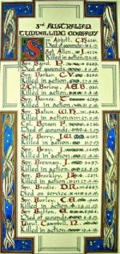
The Sydney Morning Herald - Saturday 23 July 1921:
ENGINEERS' ROLL OF HONOUR
The Royal Engineer War Memorial Committee are arranging to deposit a roll of honour of all ranks of the Royal Engineers whose names were officially published as killed in action or died of wounds or disease in the war in the chapel of St. Paul's Cathedral, and the Engineer corps of the dominions, colonial, and Indian armies have been invited to deposit similar rolls of honour in St. Paul's, to be attached to that of the Royal Engineers. This invitation has been accepted in Australia. The roll will be inscribed on vellum and enclosed in a casket of Australian timbers to rest on a slab of Australian marble.

This extract from Tunnellers Roll of Honour included in profile with the kind permission of the
Dean and Chapter of St Paul’s Cathedral, London
Photos courtesy of Robin Sanderson, Paris

The Memorial Scroll (354182) was forwarded to his father on 24 May, 1922 and the Memorial Plaque (354182) was sent direct to him on 9 October, 1922.

The Victory Medal was issued by registered post (1075) on 8 May, 1923.

Receipts for delivery of his memorabilia were: Memorial Scroll on 29 May, 1922; Memorial Plaque on 15 October, 1922 and Victory Medal on 10 May, 1923.

The After War Report for the 3rd Tunnelling Company has his name listed in their Roll of Honour as follows:

No. Rank Name Nature of Sickness Date of Death Locality Burial at
6663 Spr. Baird, P. Gas & Broncho-Pneumonia 5/11/18 2nd A.G.H. Wimmereux.

Base Records wrote to Mrs Baird on 29 August, 1929 asking on behalf of the official historian if she would kindly complete the enclosed Roll of Honor form referring to the demise of her late son and return it to their office at her earliest convenience.

In the Australian War Memorial his name is commemorated on Panel 26 in the commemorative area.

The Lithgow War Memorial also tributes his name and sacrifice.

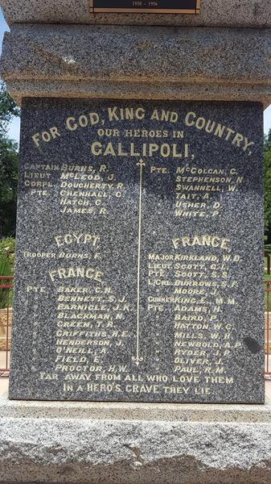
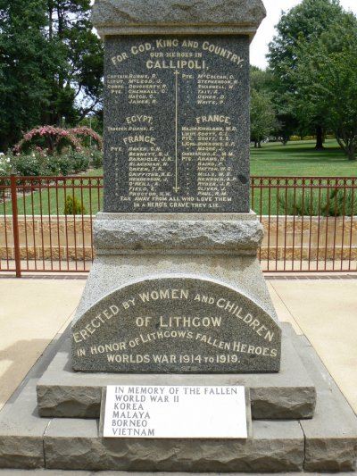
His grave is located in Plot 7 of Terlincthun British Military Cemetery, Wimile, France within row C in grave no. 20.
War Memorial Lithgow, NSW - Photo sourced from Aust War Memorial and Images of Memorial
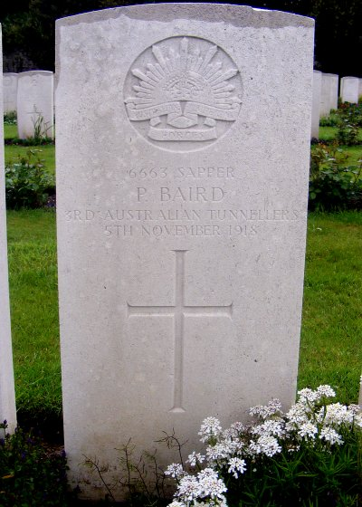
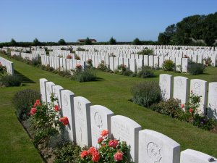
Photos of headstone and cemetery by kind permission of
The War Graves Photographic Project
www.twgpp.org

LEST WE FORGET

© Donna Baldey 2022
www.tunnellers.net

