SAPPER JOSEPH BAILEY
9523 – 2nd Tunnelling Company

Joseph (Joe) Bailey stated he was born about 1871 in Wellington, New Zealand the son of James and Elizabeth Bailey and served one year and 31 days as a farrier with the 6th New Zealand Mounted Rifles in the Boer War. There are only six men named Bailey in the nominal rolls of New Zealanders for the Boer War but none are listed with the 6th N.Z. Mounted Rifles.

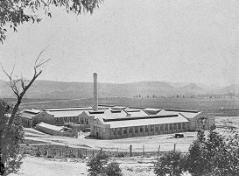
He came to Australia and during the First World War was employed at the Lithgow Small Arms Factory up to the end of 1917 leaving his occupation of miner. He resided at Sloane’s Hotel, Wellington, NSW.
Small Arms Factory – Lithgow, NSW 1912
Photo sourced from Images of Small Arms Factory

At the recruiting depot in Wellington, NSW on 12 November, 1917 the forty-four-year-old unmarried miner applied to enlist for active service abroad and passed the preliminary medical examination. Personal particulars taken reveal he was 176cms (5ft 9ins) tall, weighed 80.9kgs (178lbs) with a chest expansion of 92-102cms (36-40ins). Dark was his complexion with good vision in his hazel eyes and had black hair. Church of England was his religious faith. Distinctive marks were scars on his right knee, face and back of head. He stated he had no known next-of-kin and nominated his friend Benjamin Sloane of the Exchange Hotel, Wellington, NSW in lieu.

He was re-examined at Victoria Barracks, Sydney and noted required dental treatment. On 16 November the recruit reported to the Engineers training camp at the Showgrounds in Sydney where he remained until November 22 and moved to the Engineers Depot at Moore Park for further training. Final Leave was granted returning on November 29. On December 3 was transferred to their camp at Seymour, Victoria joining the July Reinforcements to the Tunnelling Companies for further experience. Military authorities noted his Will had been filed with them in preparation for departure. On 20 February, 1918 was moved to the 1st Depot Battalion at Broadmeadows camp in Melbourne. His rank was Sapper with the regimental number 9523.

The Reinforcements totalling 51 members departed Melbourne, Vic on February 28, 1918 on board the HMAT A71 Nestor and crossed the Pacific Ocean arriving at Colon, Panama on March 25, 1918. On March 28 the transport departed Panama and tied up at Newport News, U.S.A. on April 3 remaining there for three days and leaving port on April 6, 1918. Halifax, Nova Scotia was the next port-of-call on April 9 for a day at the wharf to refuel for the voyage to England. The voyage terminated after fifty-one days at sea at Liverpool, England on April 19 and docked where the disembarking the Reinforcements entrained to Tidworth the next day. They marched into the Aust Details No. 3 camp at Parkhouse the same day April 20, 1918 for further training for the front.

The Reinforcement proceeded from Southampton to France on May 14, 1918 arriving at the Aust General Base Depot at Rouelles the next day. Sapper was moved to the Aust Corps Depot at Pernois on May 25 marching out to join the 2nd Tunnelling Company in the field two days later and taken on strength on May 28.

His service continued until after the Armistice as the Tunnelling Companies remained on the Front as part of the Army of Occupation assisting with clearing of roads and bridges of booby traps and delayed action mines left by the enemy.

Orders were received to return to the Base Depot to prepare for repatriation to England on 3 February, 1919.
They left the Aust General Base Depot on 12 February, 1919 from Havre and crossed the English Channel arriving at the 2nd Training Brigade camp the next day to await the voyage home.

He was medically examined on 15 February, 1919 and found to have no disability from active service and fit for general service.

After demobilisation Sapper Bailey embarked from Devonport, England for Australia on 13 April, 1919 on board H.T. Castalia. Base Records advised his friend on May 16 that he was returning home. News of their arrival was published in:

The Sun Sunday 1 June, 1919
RETURNING SOLDIERS – MEN BY THE MEDIC AND CASTALIA
Soldiers ex Castalia will disembark this afternoon. Those with tickets marked Castalia from the Staff officer for Invalids will be admitted to the Anzac Buffett at 2.45p.m.
Cars on the Red Cross register from 57 to 114 will be required to be at No. 1 Wharf, Woolloomooloo at 2.45p.m.
Military discharge was issued in Sydney (2nd Military District) on 17 June, 1919 on termination of his period of enlistment.

His Will was returned to the Assistant Adjutant General at the 2nd Military District on 2 August, 1919.

The British War Medal (81001) and the Victory Medal (76727) were issued to Sapper 9523 Joseph Bailey, 2nd Tunnelling Company for serving his country.

He returned to the Wellington District of New South Wales and was residing at M.R.B. Wallerawang working as a labourer in 1930 and in 1933 was listed at Race Course, Wallerawang and still a labourer. By 1935 he was at 33 Lee Street, Wellington and a miner and from 1943 onward was on the roll at Wallerawang as a miner.

The Sydney Branch of the Repatriation Department requested a Statement of his Service from Base Records which was forwarded on 8 February, 1937.

Joseph Bailey passed away in the Portland Hospital on 23 July, 1950 aged 79 years and a small Obituary was published in the:
Lithgow Mercury Thursday July 25, 1950:
DEATH OF WANG RESIDENT – MR J. BAILEY
After a long illness, the last seven weeks of which were spent in hospital, Mr Joseph Bailey, of Wallerawang, passed away on Tuesday morning at the age of 79 years.
Mr Bailey was born in New Zealand and had no relatives in this country. Deceased was a resident of Wallerawang for a number of years.
Of a rather reserved disposition, he was respected by all who knew him, this being evident as the funeral, which was largely attended.
Employed at the Small Arms Factory, Lithgow, during the war period he had lived a quiet life and had not worked since.
Prior to the cortege leaving St John’s Church of England, a short service was conducted by Rev. W.F. Carter, who also officiated at the graveside in Wallerawang Cemetery.
Representatives of the Wallerawang branch of the Returned Soldiers’ League preceded the cortege.
Mr Bailey served in three wars.
Pallbearers were Messrs C. Dodd and P. Lane. There were numerous floral tributes.
Funeral arrangements were in the hands of J. Simpkins, Portland.

Interment took place in Wallerawang Cemetery, NSW with Rev. W.F. Carter officiating at the graveside.

Further tributes were published in the:
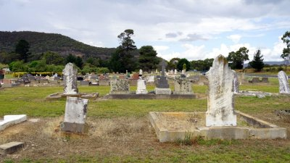
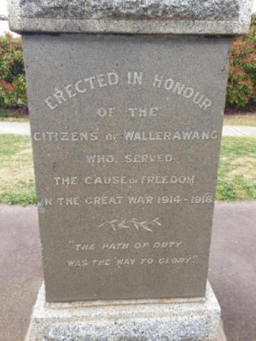
Lithgow Mercury Monday July 31, 1950:
NEWS FROM WALLERAWANG
As already reported in the “Mercury” the death occurred in Portland hospital earlier this week of Digger “Joe” Bailey, who for many years was a resident of Wang. “Joe” who was well known and liked by all had had a considerable military service and was a veteran of three wars. He was a native of New Zealand, and as far as is known had no relatives in Australia, but by his honesty of purpose and good nature was the friend of many, esteemed by all who knew him. Of sprightly and energetic appearance, he belied his actual age of 79, and could be easily taken for a man much younger. He was a member of the local sub-branch of the R.S.L. and members of this organisation acted as pall bearers for the interment.
A Section of Wallerawang Cemetery, NSW
Photo sourced from Find-a-Grave website
Wallerawang War Memorial 1914-1918
Photo sourced from Wallerawang Images Public Domain

© Donna Baldey 2022
www.tunnellers.net

